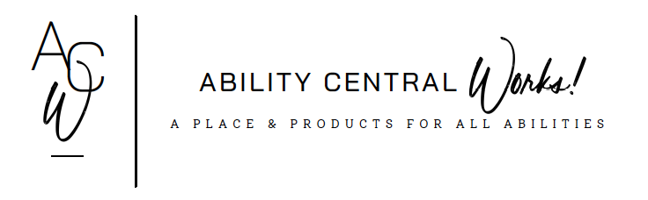
TEAM MEMBER APPLICATION

The Admissions Committee conducts a thorough review of the information provided. The purpose of the review is to determine if the programming provided at Ability Central is suitable for the applicant. Unfortunately, at this time, accessibility is a barrier as the facility does not have a handicap accessible restroom.

Applicant Name: |  |  |  | Date:
Date of Birth: |  |  |  | Phone #:
Address:
Gender: |  |  | Height: |  |  |  | Weight:
Guardian Name:
Guardian’s relationship to applicant:
Address
(if different):
Phone: |  |  |  | Email:

PLEASE PROVIDE DESCRIPTIONS OF THE FOLLOWING:
Diagnosis/Disability:

General health:

Medical concerns and/or physical disabilities:

Medications and their purpose:

Allergies:

Dietary restrictions:

Communication abilities:

Typical temperament:

Behavioral challenges:

Is there a history of self-injurious behaviors? If yes, please describe.

Is there a history of aggression towards others? If yes, please describe.

Self-help skills:

Typical daily routine:

Preferences for spending free time:

Interests:

Strengths:

Is the applicant currently receiving any services or therapies?

In what types of programs has the applicant participated after completing high school?

Has the applicant ever been involved with tobacco, drug abuse, criminal activity, or sexual misconduct? If yes, please explain.

Please describe your goals and expectations for the applicant.

What do you hope the applicant will accomplish through participation in Ability Central’s program?

Is there any other information you feel we should know about the applicant?

Please list two individuals who have worked closely with the applicant and would be willing to discuss the applicant’s abilities. Please include the relationship to the student and a phone number by which they can be reached.
Name
Relationship to applicant:
Phone #:

Name
Relationship to applicant:
Phone #:

Your signature affirms that the information provided in this application is a complete and true statement of the applicant’s abilities and circumstances.

Your signature provides permission for Ability Central to contact references, programs, and professionals listed in this application to request information about the applicant. It also authorizes anyone who has information on the applicant to release information to Ability Central.

Signature of Guardian: _____________________________________________ Date: ___________________________

